Proiect An 3 Calculatoare (Varianta 2)

**Echipa: 10**

**Membrii:**

* **Cepoiu Radu-Constantin 232/1 (Responsabil de proiect)**
* **Onofrei Darius 231/2**
* **Alexandru Marian 232/1**
* **Eduard Tira 232/1**
* **Radu Cruceat 232/1**

**InHumanResources**

1. **Scop**

Proiectulde fata isi propune studierea si aplicarea unor probleme din domeniul inginerei software. Ingineria software este descrisa pe scurt ca “un proces de analiză a cerințelor utilizatorilor și apoi proiectarea, construirea și testarea aplicației software care va satisface aceste cerințe”.

De asemenea proiectul are ca scop utilizarea tehnologiilor Java EE studiate la laborator.

1. **Analiza cerințelor aplicației**

* **Problem description**

The "InHuman Resources" application serves as a comprehensive software solution for employee administration and salary calculation. It streamlines the entire employee management process and ensures precise salary calculations while providing a user-friendly experience for administrators.

The app facilitates the storage, modification, and deletion of relevant employee data, ensuring an up-to-date and accurate database. Users can access and manage essential information such as personal details, address, salary class, bonuses, tax details, working hours, and more.

The system automates the complex process of salary calculation based on different criteria for lecturers, associate professors, and professor. It includes features for handling monthly basic salaries, bonuses for success, shares for executives, and additional bonuses.

The application provides role-based access control, allowing administrators and employees to access the system with appropriate privileges. Access is restricted to ensure data security and privacy, with different levels of permissions for various user roles.

The app boasts an intuitive and comfortable user interface, making it easy for both administrators and employees to navigate and interact with the system. The interface ensures efficient data entry, modification, and retrieval, enhancing overall user experience.

Automation is integrated into critical processes, including monthly salary calculations, fund transfers, and the generation of detailed salary sheets. This automation reduces the risk of errors and enhances the efficiency of routine tasks.

* **User stories**
* As an Admin, I want to log in to my account with elevated privileges for user account management.
  + Acceptance Criteria:
    - The system verifies the username and password for authentication.
    - Admin status grants access to user account management features.
    - Limited access is granted for non-admin accounts.
* As an Admin, I want to log out of my account to ensure system security.
  + Acceptance Criteria:
    - A logout button is available for Admin to disconnect from the account.
    - The system logs off the Admin when the logout button is pressed.
* As a General Director I want to login to my account as the highest admin authority to manage users
  + Acceptance Criteria:
    - The username and password will be checked by the program
    - If the account has the permission to manage users, it will gain admin status
    - Else it will gain limited access to the infrastructure
* As a General Director I want to logout to my account
  + Acceptance Criteria:
    - I will press the log off button if I want to disconnect from my account
    - The system will log me off
* As an Employee, I want to access and update my personal information, including contact details and emergency contacts, to keep my records accurate and up to date.
  + Acceptance Criteria:
    - The system should provide a user-friendly interface for editing personal information.
    - Changes made to personal information should be saved and reflected accurately in the employee's profile.
    - A confirmation message should be displayed upon successful updates.
    - Otherwise, the system should display an error message if it's unable to update the information.
* As an Employee, I need to submit leave requests to efficiently request time off and plan my work schedule effectively.
  + Acceptance Criteria:
    - The system should offer a leave request feature with options for specifying leave type, dates, and additional details.
    - Leave balances should be updated in real-time, reflecting approved or declined requests.
    - Employees should receive notifications about the status of their leave requests.
    - Otherwise, the system should display an error message if it encounters issues with leave request submission.
* As a HR Director I want to open a new position to get new validated employees to have access over it.
  + Acceptance Criteria -
    - System validates username and password
    - System validates hr director role
    - General Director approves of the new position
    - After system validation if everything is ok, you can open position
    - Otherwise system displays restricted access
* As a HR Manager I want to edit a position to clarify the requirements.
  + Acceptance Criteria –
    - User is logged in with General Director, Department Director, HR Director or Recruiter privileges
    - All the modified values are validated by system checks
    - The position is updated
* As a Team Manager, I want to update the list of people in my team, to keep track of all the people in my team.
  + Acceptance Criteria:
    - The system should provide a user-friendly interface for editing team information.
    - Changes made to team’s information should be saved and reflected accurately in the team’s profile.
    - A confirmation message should be displayed upon successful updates.
    - Otherwise, the system should display an error message if it's unable to update the information.
* **Use Case-uri / Diagrama de use case-uri**

|  |  |
| --- | --- |
| Autor | Marian Alexandru |
| Use Case | Send Feedback |
| Actors | Employee |
| Preconditions | * User has something useful to “say” about the “Inhuman Resources” system (it can be good or bad); * User is authenticated and has employee privileges; |
| Postconditions | * Receive a message like “your feedback has been sent” |
| Trigger | Click button “send my feedback” |
| Main Scenario | 1. User selects option “send feedback”; 2. User types one or more ideas(improvements) that he thinks are suitable; 3. At the end, user presses “enter” key or clicks on “send my feedback” option to send the message (to cancel press x button); 4. System sends his review to higher authorities from the system; |
| Alternative Flow 1 | 1. User clicks the “just save and exit” button to save the feedback but not send it, also it exits from that screen. 2. Later, if he wants to add/send/remove from/to his feedback it will be saved from the last time (as long as the system hasn’t been powered off) 3. To clear feedback user can press on x button and the feedback will be deleted and it will exit the feedback screen; |
| Exceptions | 1. System detects incorrect user authentification (wrong password or user id)    1. System displays an error message;    2. System loads login page;    3. User can reenter his info; |

|  |  |
| --- | --- |
| Autor | Cruceat Radu |
| Use Case UC1 | View Personal Info |
| Actors | Employee |
| Preconditions | User is identified and authenticated |
| Postconditions | The user can check his personal info |
| Trigger | After the User presses View Personal Info button |
| Main Scenario | 1. The user logs in with his/her username and password 2. The system finds the user account using his/her entered information 3. The system checks the person’s role in the company 4. If the information is correct (it is in the system database) the system logs in the user having his associated role 5. The user presses the View Personal Info button 6. The system checks the Information associated with the account in its database. 7. The system displays the requested information in the same tab 8. The user can see the data in the tab and can be closed |
| Alternative Flows |  |
| Exceptions | 1. The user account name or passowrd is incorrect or it is not registered in the system    1. The system displays inccorect login information    2. The applicant corrects the field with correct info or he/she requests to be added to the database 2. The user Personal Data is incomplete    1. The system displays the incomplete data as empty |

|  |  |
| --- | --- |
| Autor | Cepoiu Radu-Constantin |
| Use Case | Request Vacation Time |
| Actors | Employee |
| Preconditions | User is identified and authenticated |
| Postconditions | Vacation time request is sent to HR to be reviewed |
| Trigger | Employee clicks the „Request Vacation Time” button |
| Main Scenario | 1. Employee clicks the „Request Vacation Time” button 2. A page opens that contains some forms for filling vacation time information 3. Employee fills the form for vacation time interval as desired 4. Employee fills the form for reason for vacation time request (optionally) 5. Employee clicks the Send button |
| Alternative Flows | 1. Employee clicks the „Cancel” button anywhere on the „Request Vacation Time” page 2. Employee is sent back to the page previous to the „Request Vacation Time” page, canceling the request |
| Exceptions | If request vacation time form is filled improperly:   1. Display error regarding the issue 2. Cancel the sending of the request   If no vacation time is available for current user:   1. Display error regarding this issue 2. Send the user back to the page where „Request Vacation Time” button was clicked |

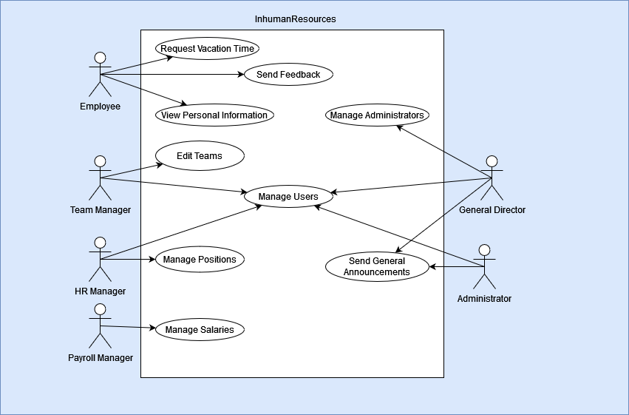

* **Diagrame SSD**

# Request Vacation Time

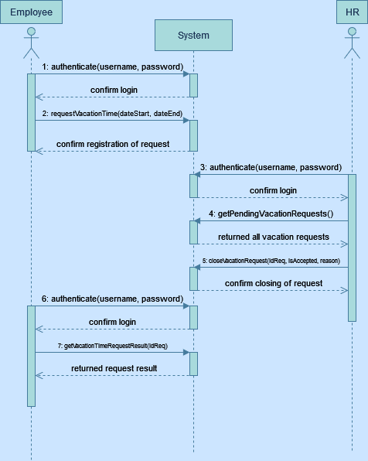

1. **Design și implementare**

* Diagrama de clase